 | Skill | Representations and Methods
Addition | Add 1-digit numbers within 10 | 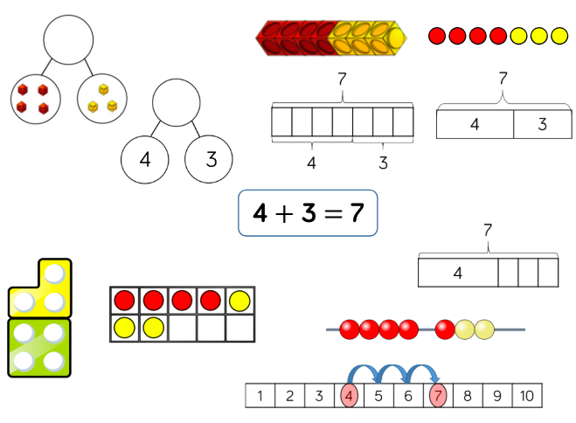 | Part-whole model  Bar model  Number shapes  Ten frames (within 10)  Bead strings (10)  Number tracks
 | Add 1 and 2 -digit numbers to 20 | 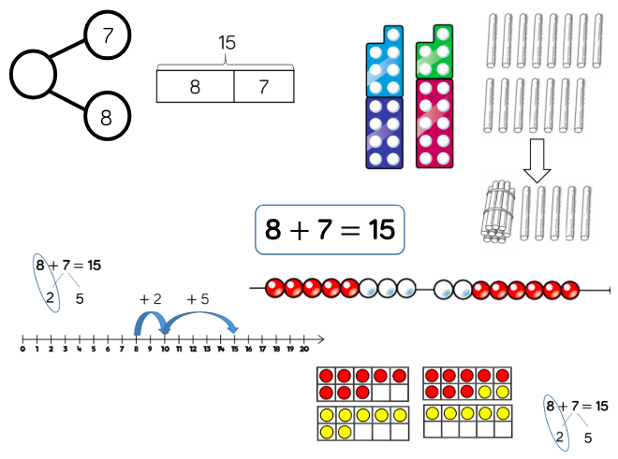 | Part-whole model  Bar model  Number shapes  Ten frames (within 20)  Bead strings (20)  Number tracks  Number lines (labelled)  Straws
Subtraction | Subtract 1-digit numbers within 10 | 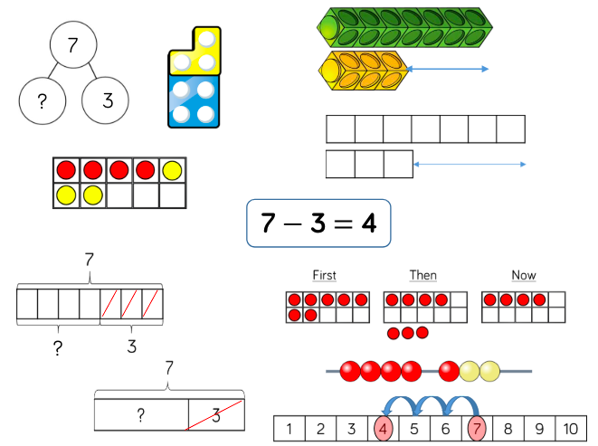 | Part-whole model  Bar model  Number shapes  Ten frames (within 10)  Bead strings (10) Number tracks
 | Subtract 1 and 2-digit numbers to 20 | 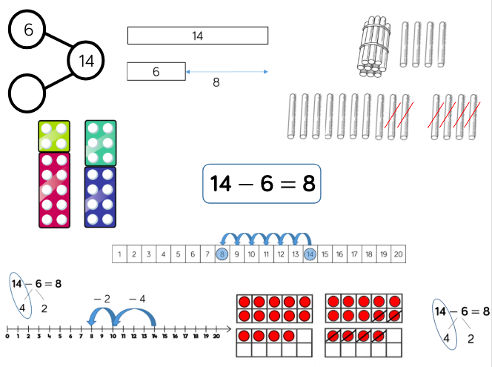 | Part-whole model  Bar model  Number shapes  Ten frames (within 20)  Bead string (20)  Number tracks  Number lines (labelled)  Straws
Multiplication | Solve 1-step problems using multiplication | 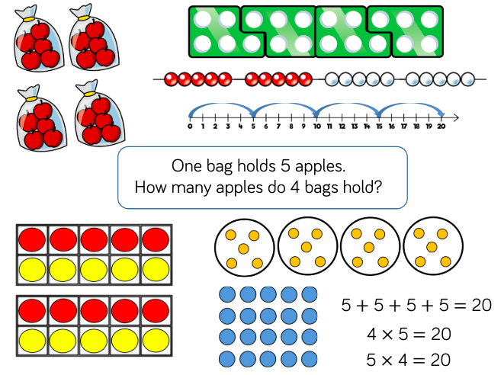 | Bar model  Number shapes  Counters  Ten frames  Bead strings  Number lines
Division | Solve 1-step problems using multiplication (sharing) | 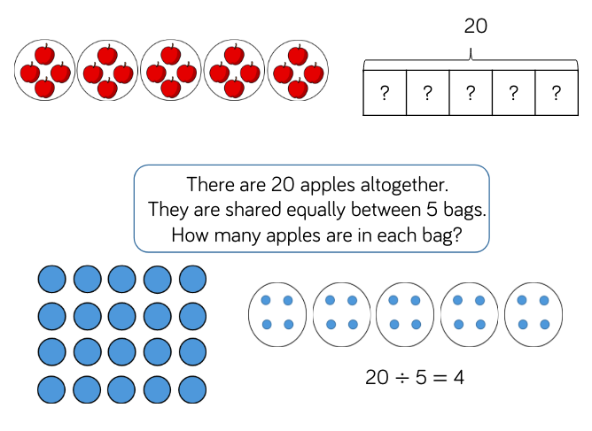 | Bar model  Real life objects  Arrays  Counters
 | Solve 1-step problems using division (grouping) | 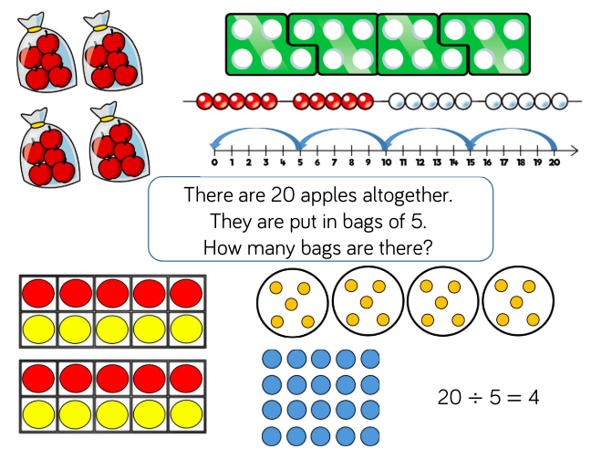 | Real life objects  Number shapes  Bead strings  Ten frames  Number lines  Arrays  Counters

