 | Skill | Representations and Methods
Addition | Add 1 and 2 digit numbers to 20 | 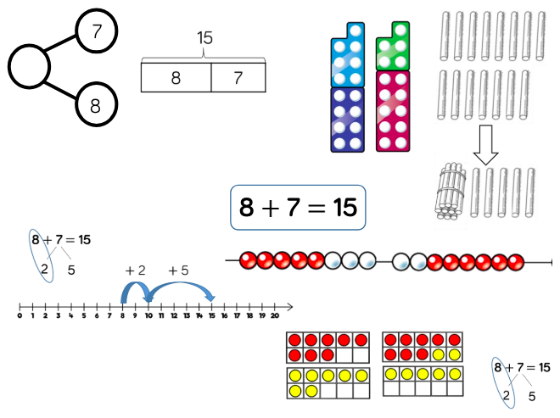 | Part-whole model Bar model Number shapes Ten frames (within 20) Bead strings (20) Number tracks Number lines (labelled) Straws
 | Add three 1-digit numbers | 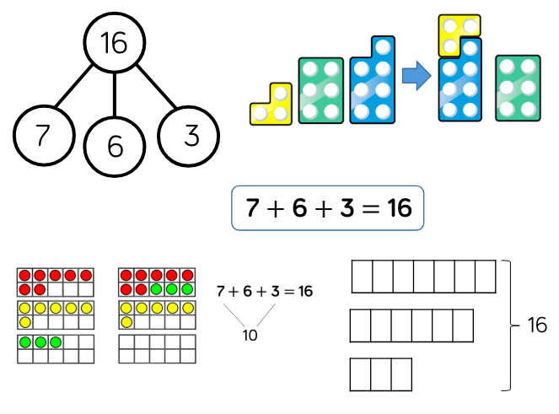 | Part-whole model Bar model Ten frames (within 20) Number shapes
 | Add 1 and 2-digit numbers to 100 | 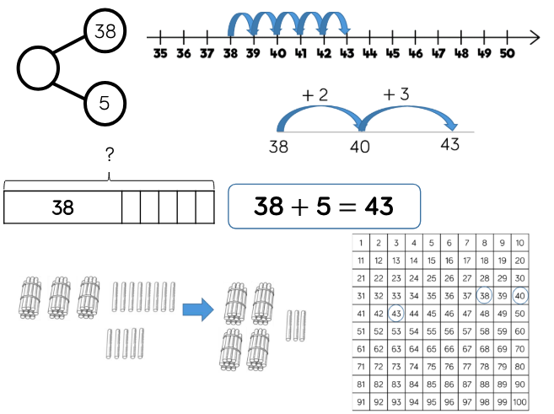 | Part-whole model Bar model Number lines (labelled) Number lines (blank) Straws Hundred square
 | Add two 2-digit numbers | 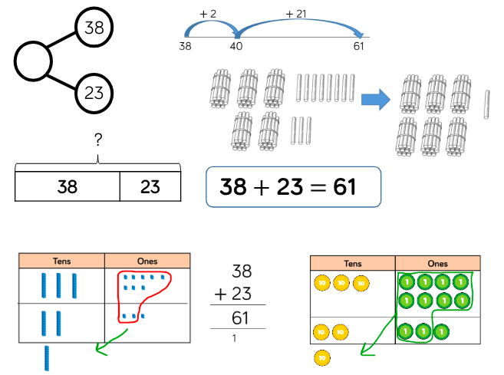 | Part-whole model Bar model Number lines (blank) Straws Base 10 Place value counters  Column method
Subtraction | Skill: Subtract 1 and 2-digit numbers to 20 | 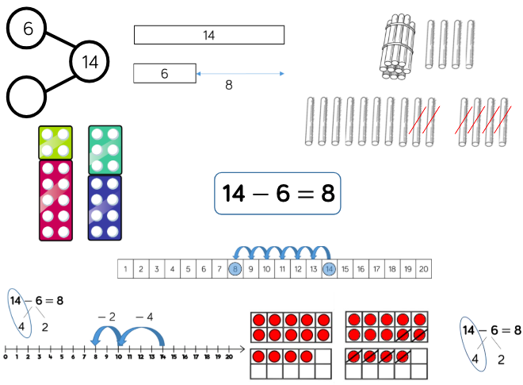 | Part-whole model  Bar model  Number lines (labelled)  Number lines (blank)  Straws  Hundred square
 | Skill: Subtract 1 and 2-digit numbers to 100 | 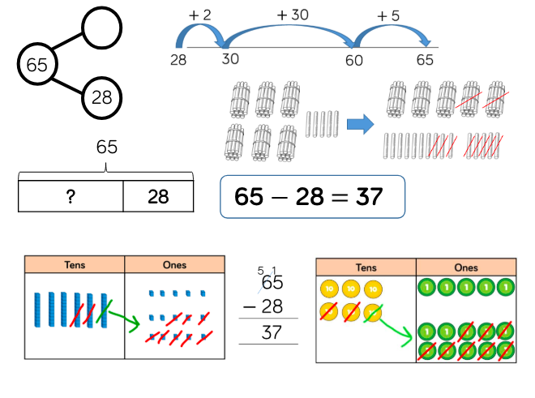 | Part-whole model  Bar model  Number lines (blank)  Straws  Base 10  Place value counters  Column Method
Multiplication | Solve 1-step problems using multiplication | 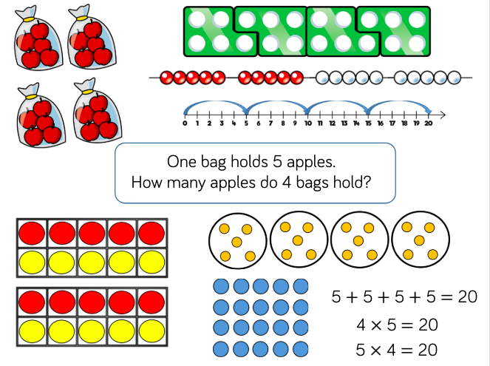 | Bar model  Number shapes  Counters  Ten frames  Bead strings  Number lines
Division | Solve 1-step problems using multiplication (sharing) | 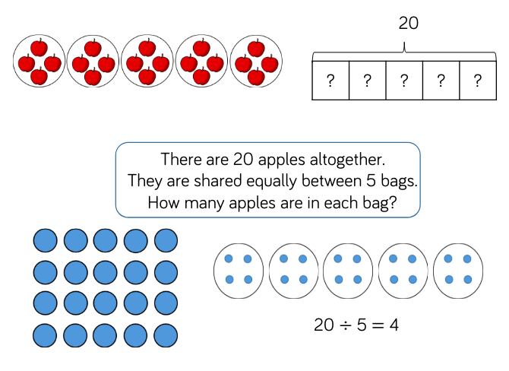 | Bar model  Real life objects  Arrays  Counters
 | Solve 1-step problems using division (grouping) | 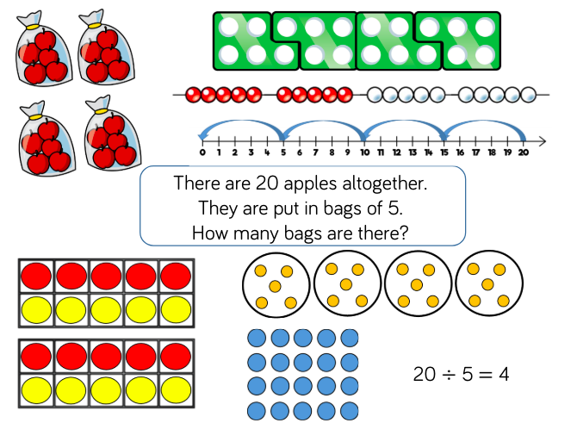 | Real life objects  Number shapes  Bead strings  Ten frames  Number lines  Arrays  Counters

