 | Skill | Representations and Methods
Addition | Add 1-digit and 2-digit numbers to 100 | 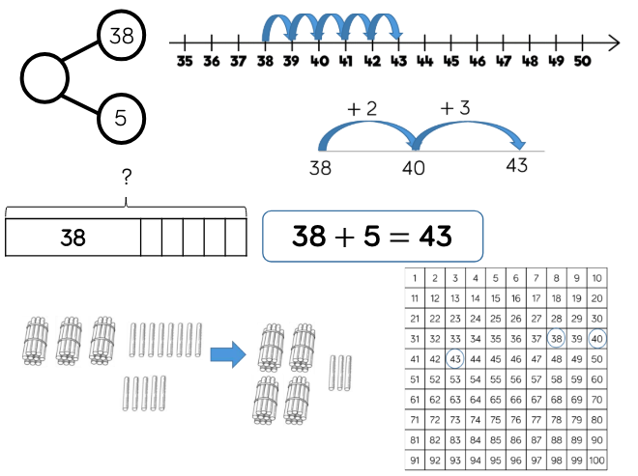 | Part-whole model  Bar model  Number lines (labelled)  Number lines (blank)  Straws  Hundred square
 | Add two 2-digit numbers to 100 | 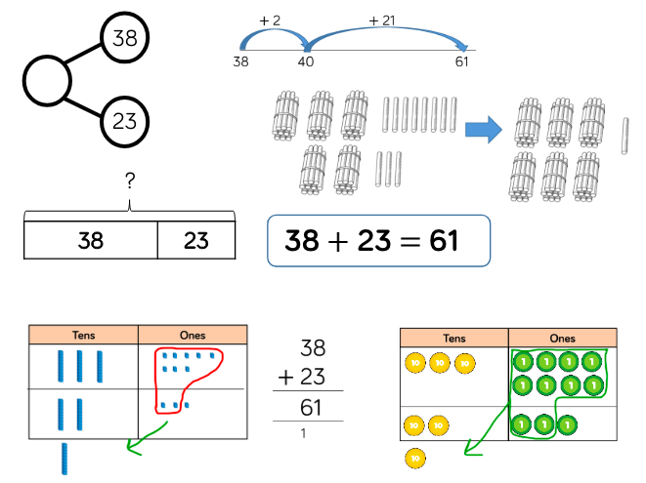 | Part-whole model  Bar model  Number lines (blank)  Straws  Base 10  Place value counters  Column addition
 | Add numbers with up to 3 digits | 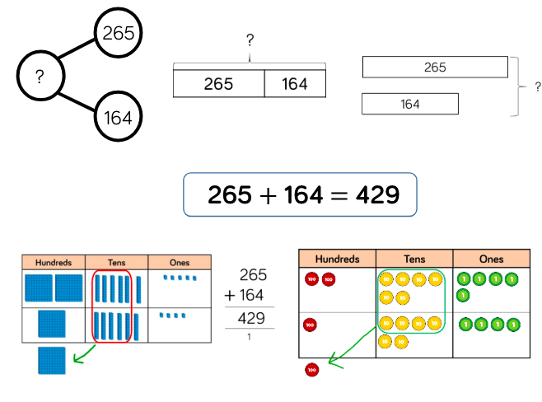 | Part-whole model  Bar model  Base 10  Place value counters  Column addition
Subtraction | Subtract 1 and 2-digit numbers to 100 | 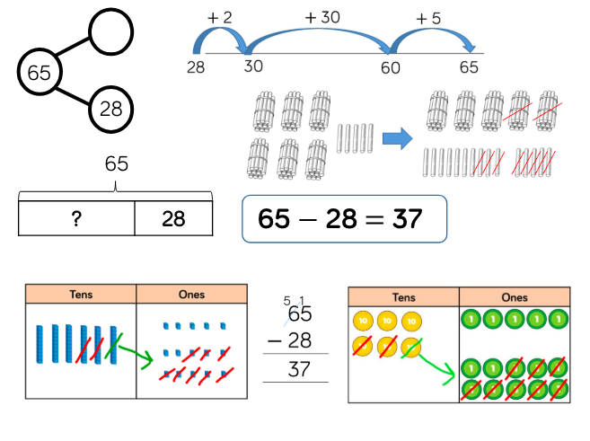 | Part-whole model  Bar model  Number lines (blank)  Straws  Base 10  Place value counters  Column subtraction
 | Subtract numbers with up to 3 digits | 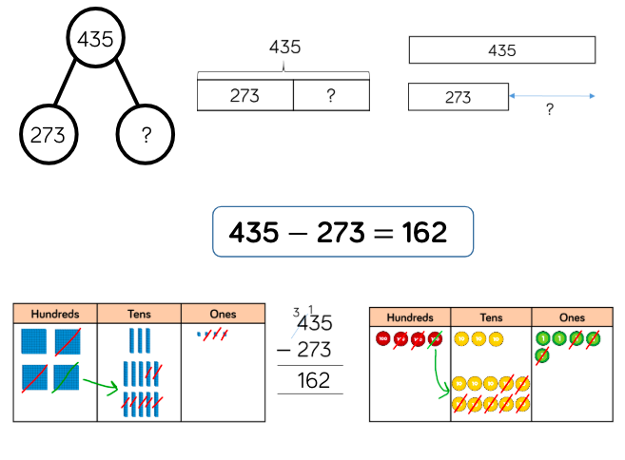 | Part-whole model  Bar model  Base 10  Place value counters  Column subtraction
Multiplication | Multiply 2-digit by 1- digit numbers | 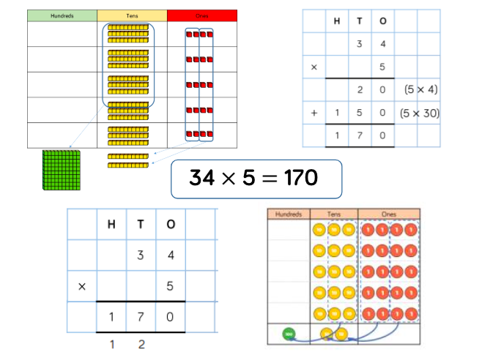 | Place value counters  Base 10  Expanded written method  Short written method
Division | Divide 2-digits by 1-digit (sharing with no exchange) | 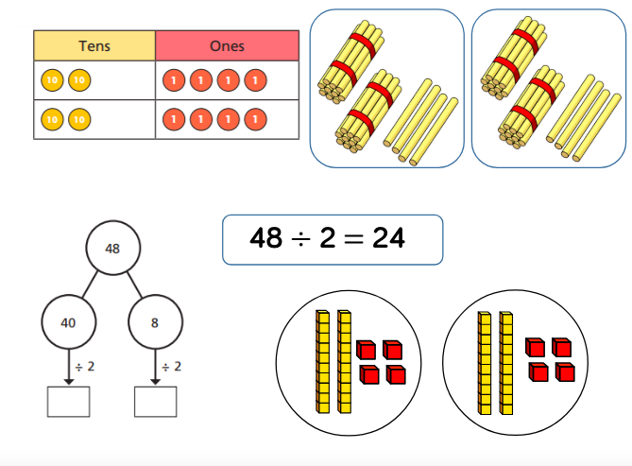 | Straws  Base 10  Bar model  Place value counters  Part-whole model
 | Divide 2-digits by 1-digit (sharing with exchange) | 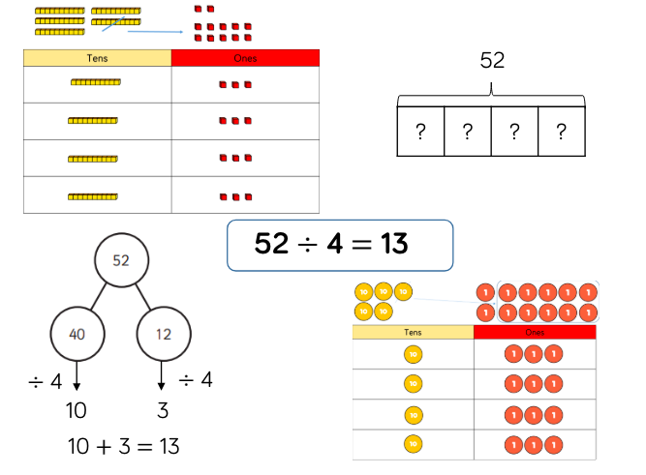 | Straws  Base 10  Bar model  Place value counters  Part-whole model
 | Divide 2-digits by 1-digit (sharing with remainders) | 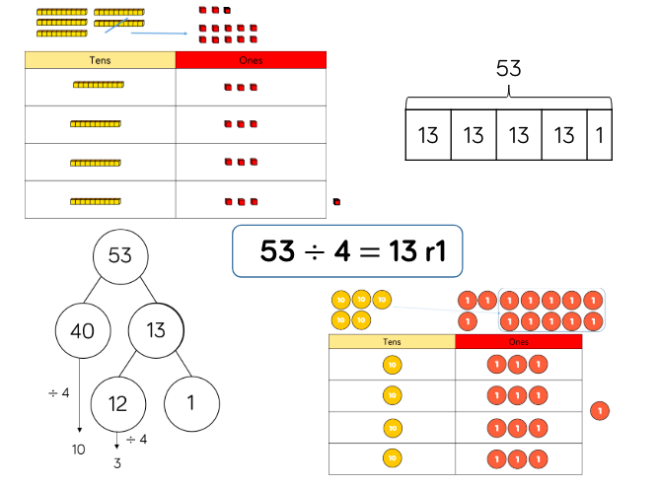 | Straws  Base 10  Bar model  Place value counters  Part-whole model

