 | Skill | Representations and Methods
Addition | Add numbers with up to 4 digits | 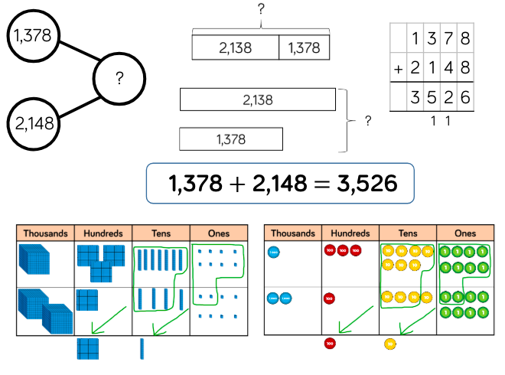 | Part-whole model  Bar model  Base 10  Place value counters  Column addition
Subtraction | Subtract numbers with up to 4 digits | 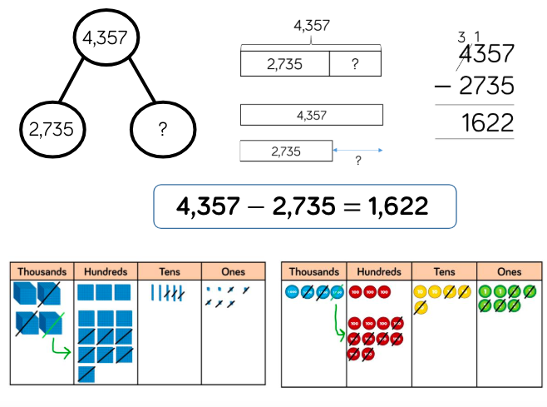 | Part-whole model  Bar model  Base 10  Place value counters  Column subtraction
Multiplication | Multiply 2-digit numbers by 1-digit numbers | 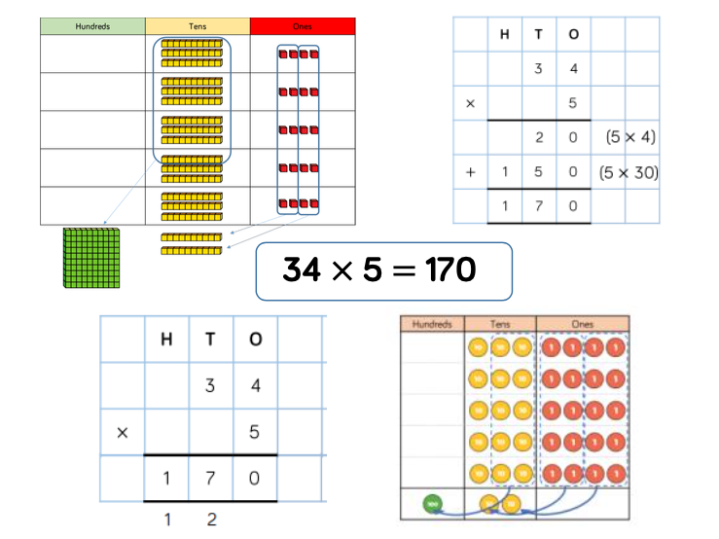 | Place value counters  Expanded written method  Base 10  Short written method
 | Multiply 3-digit numbers by 1-digit numbers | 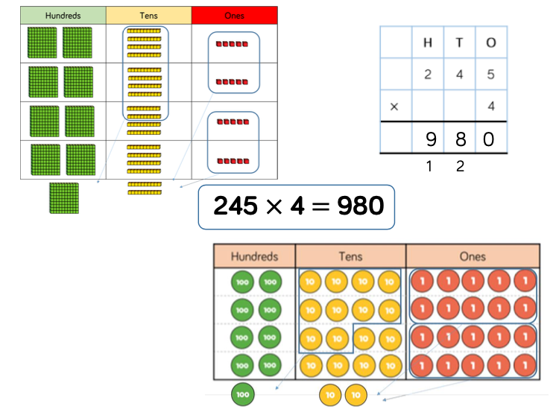 | Place value counters  Base 10  Short written method
 | Divide 2-digits by 1-digit (sharing with exchange) | 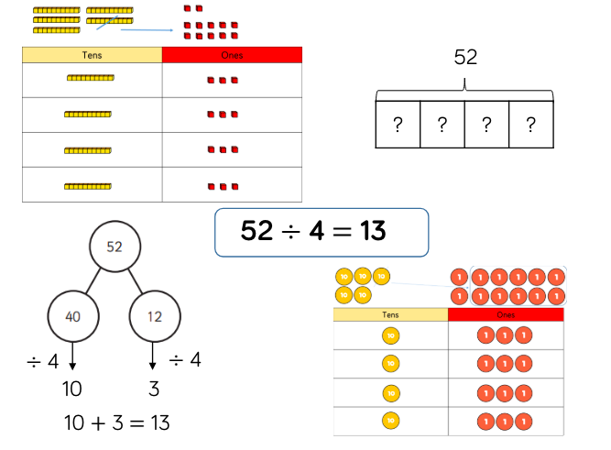 | Base 10  Bar model  Place value counters  Part-whole model
 | Divide 2-digits by 1-digit (sharing with remainders) | 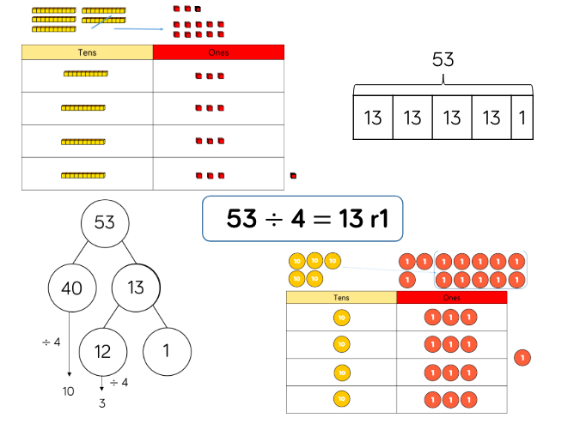 | Base 10  Bar model  Place value counters  Part-whole model

