 | Skill | Representations and Methods
Addition | Add numbers with more than 4 digits | 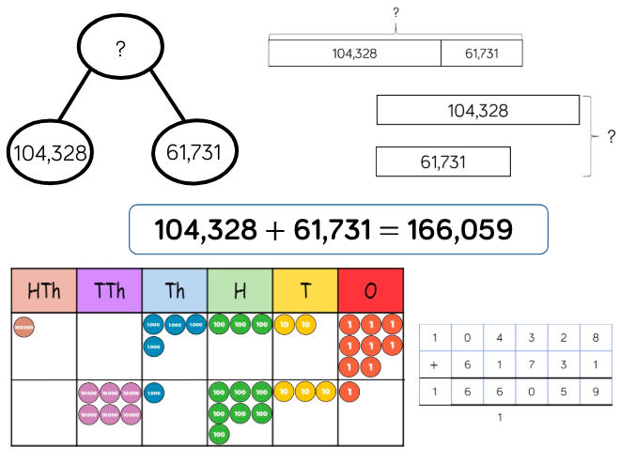 | Part-whole model  Bar model  Place value counters  Column addition
 | Add with up to 3 decimal places | 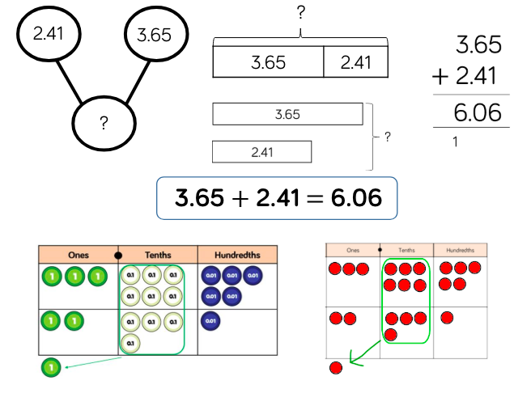 | Part-whole model  Bar model  Place value counters  Column addition
Subtraction | Subtract numbers with more than 4 digits | 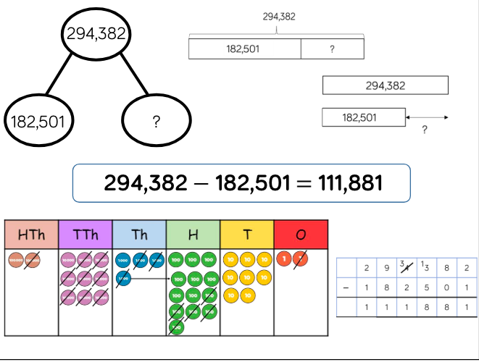 | Part-whole model  Bar model  Place value counters  Column subtraction
 | Subtract with up to 3 decimal places | 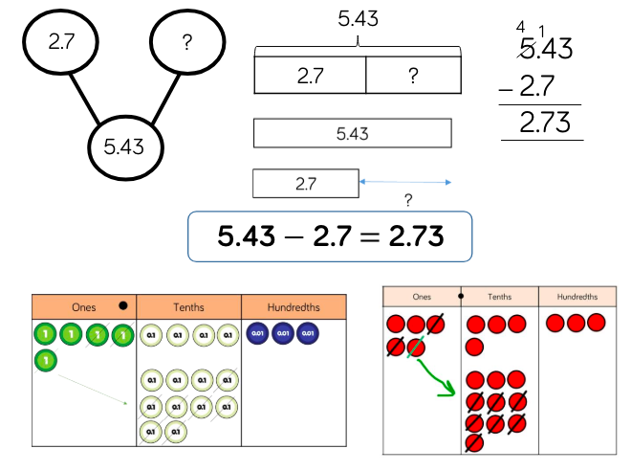 | Part-whole model  Bar model  Place value counters  Column subtraction
Multiplication | Multiply 4-digit numbers by 1-digit numbers | 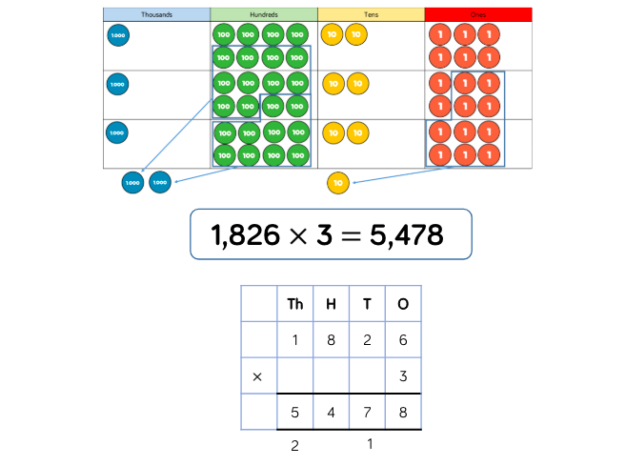 | Place value counters  Short written method
 | Multiply 2-digit numbers by 2-digit numbers | 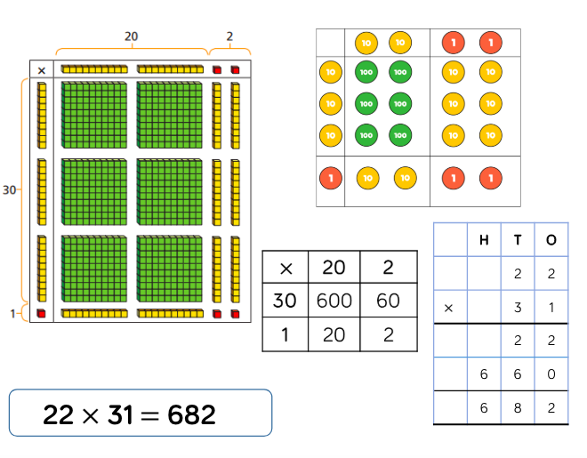 | Place value counters  Base 10  Short written method  Grid method
 | Multiply 3-digit numbers by 2-digit numbers | 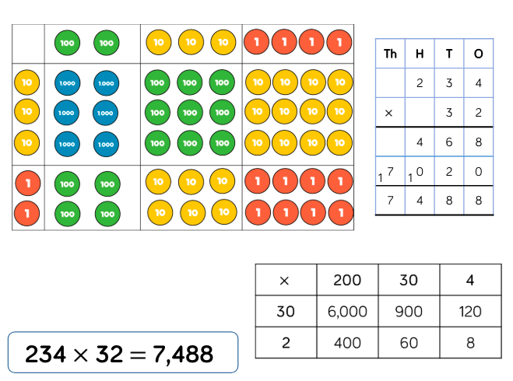 | Place value counters  Short written method  Grid method
 | Multiply 4-digit numbers by 2-digit numbers | 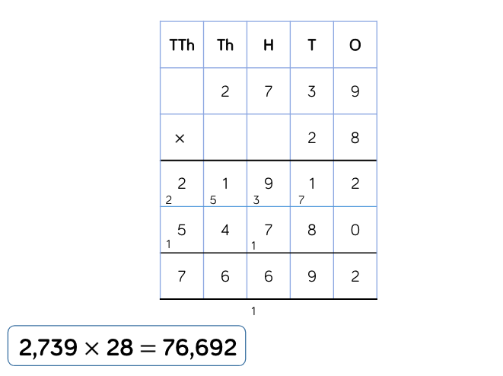 | Formal written method
Division | Divide 3-digits by 1-digit (grouping) | 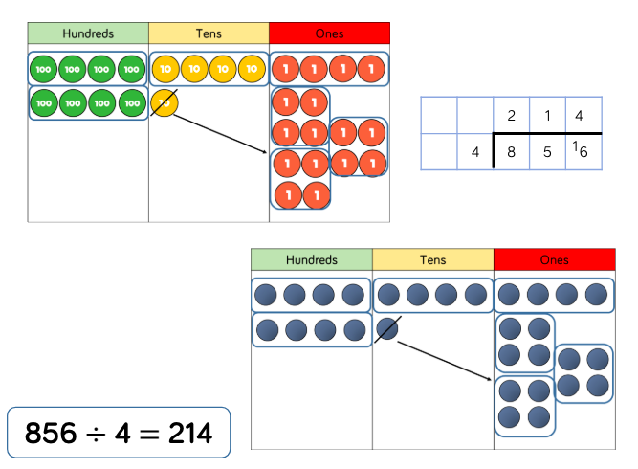 | Place value counters  Plain counters  Place value grid  Written short division
 | Divide 4-digits by 1-digit (grouping) | 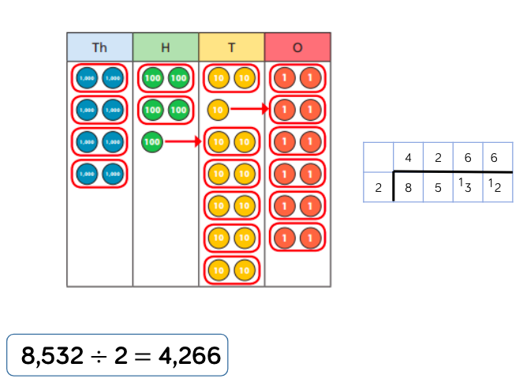 | Place value counters  Plain counters  Place value grid  Written short division

