 | Skill | Representations and Methods
Addition | Add numbers with more than 4 digits | 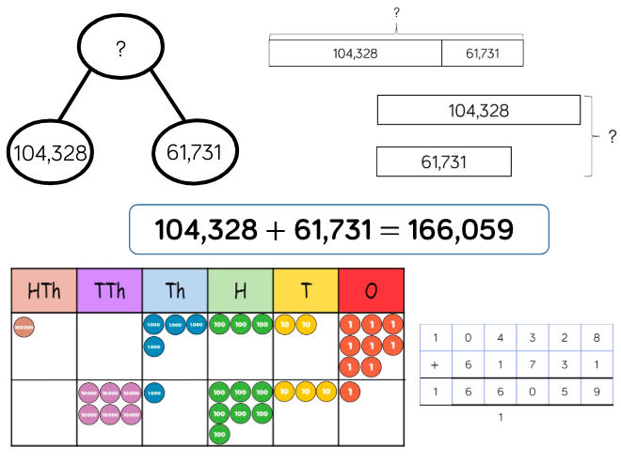 | Part-whole model  Bar model  Place value counters  Column addition
 | Add with up to 3 decimal places | 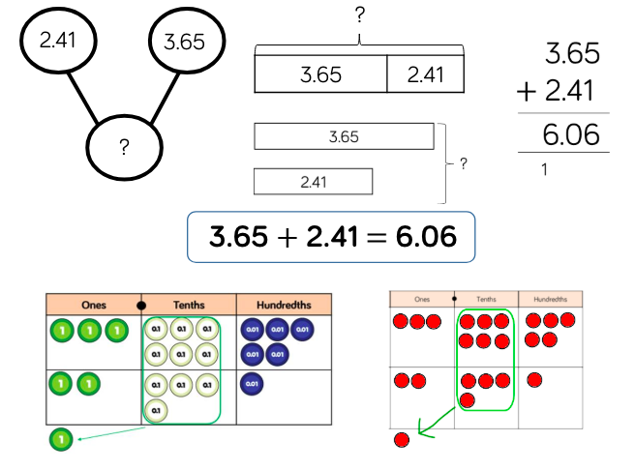 | Part-whole model  Bar model  Place value counters  Column addition
Subtraction | Subtract numbers with more than 4 digits | 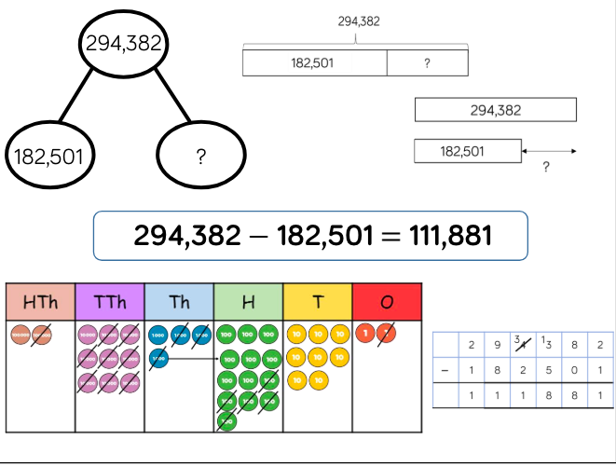 | Part-whole model  Bar model  Place value counters  Column subtraction
 | Subtract with up to 3 decimal places | 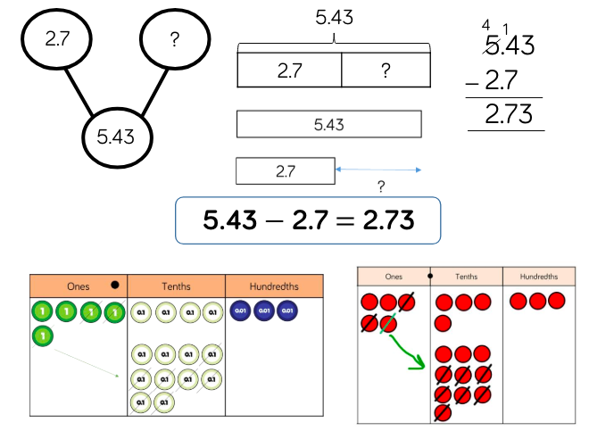 | Part-whole model  Bar model  Place value counters  Column subtraction
Multiplication | Multiply 4-digit numbers by 2-digit numbers | 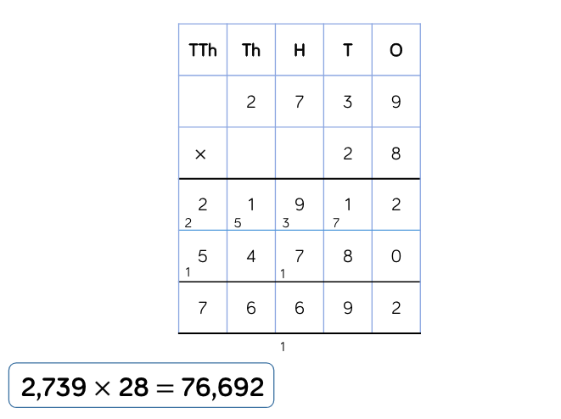 | Formal written method
Division | Divide multi digits by 2-digits (short division) | 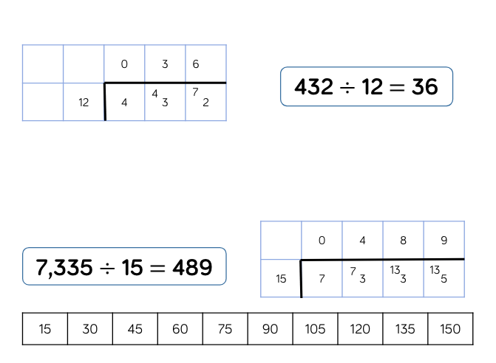 | Written short division  List of multiples
 | Divide multi-digits by 2-digits (long division) | 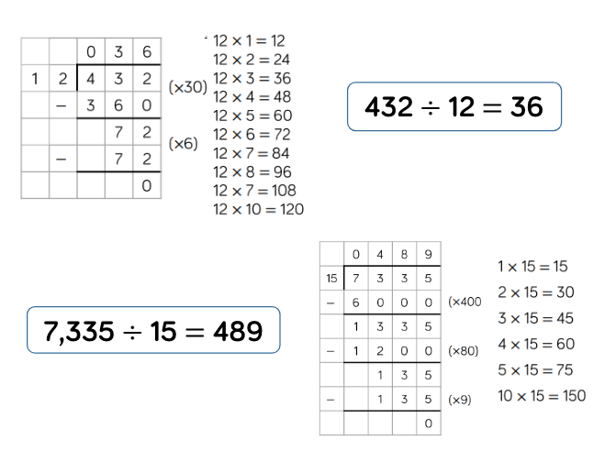 | Written short division  List of multiples
 | Divide multi digits by 2-digits (long division with remainders) | 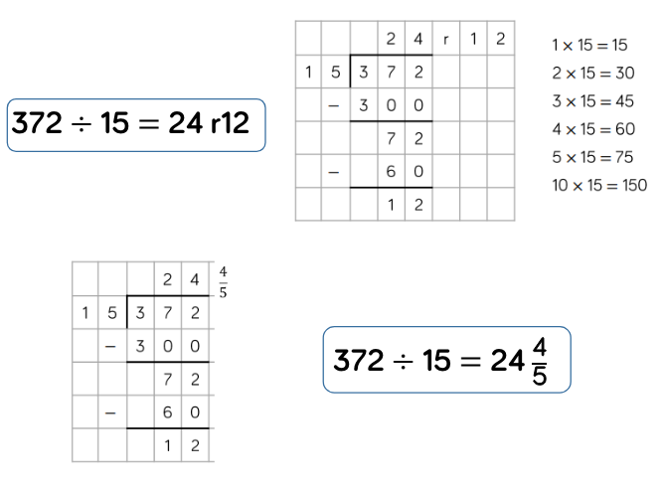 | Written short division  List of multiples

